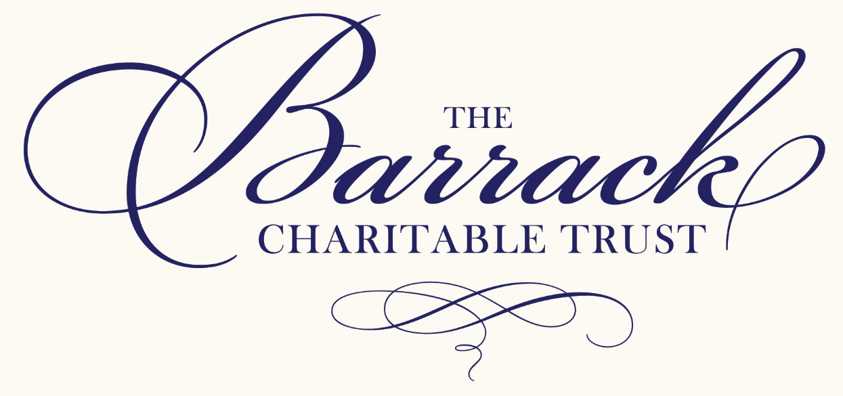

GRANT APPLICATION FORM

Read the Advice to Applicants carefully before completing this form to ensure that the organisation is eligible
and the activities for which a grant is being sought match The Trust’s categories of interest.
•
Ensure all parts of this form are completed and submitted in pdf format
•
Ensure that you use only the space provided (a small quantity of supplementary information may be supplied)
•
Ensure that an appropriate trustee or official of the organisation signs the form
•
Provide a short covering letter introducing the application and any other information you consider appropriate
•
Ensure a copy of your latest annual report and audited accounts are attached in pdf format

SCOTTISH CHARITY NO. SC040677



PART ‘A’
Type here
A1. Name of the Organisation

Property Name No.
Address
Address
Address
Address
Address
Postcode
A2. Address for Correspondence

Type here (please include area code)
A3. Telephone number

Type here
A4. Email Address
(This will be used to acknowledge receipt)

Type Charity No. Here
A5. What is the legal status of the organisation
Registered Charity organisation
Y/N
Registration Pending
Other

Please Explain here

A6. Summarise the purpose of
the application
Type here

Type here (include analysis of costs if appropriate)
A7. What is the total cost of
The project

A8. Total amount requested
from The Trust
Type here £

A9. Where do the grant
Beneficiaries live?
Type here

Type here
A10. Name of contact person

Type here
A11. Position in the organisation

CHAIR:

TREASURER:

SECRETARY:

SENIOR EMPLOYEE:
(Inc. Job Title)

One of these personnel must sign the application
A12. Please list the organisations
key personnel

A13. Social Media Information
Website Address :

Twitter :

Facebook :

PART ‘B’
Type here
B1. In which year did the
organisation start up?

Y/N
B2. Does it have a formal
constitution?

Type here
B3. Briefly describe the aims,
Objectives and activities of
the organisation

Y/N
(This could be several years ago under a different organisation name - please provide details)
B4. Has an application been
made to the Barrack
Charitable Trust before?

Type here
B5. If an application(s) has been
made before, please state the
outcome and, if grant(s) were
made, how successful they
were?

PART ‘C’
Type here
C1. What will the grant from The Barrack Charitable Trust be used for and what evidence is there that assistance is needed.
Include project start date and/or date funds are required.

PART ‘D’
D1. What other applications for funding have been made for this programme/project, to whom you have applied and what is the current status of these applications?
Type here

12 Months covered by accounts from to
D2. What is the total annual
income and expenditure of
the organisation? Please
provide a copy of the most
recent annual accounts.
TOTAL INCOME:
TOTAL EXPENDITURE:

D3. What reserves does the
organisation hold?
Restricted funds:
Unrestricted funds:

Make Cheques payable to:
D4. If the application is
successful to who should
funds be made payable.

Electronic Transfer:
Name of bank:
Sort Code: Account No.

DECLARATION
When the application form has been completed, an authorised Trustee or Official of the applicant organisation must sign the declaration below and email it to trust@barrack.org in pdf format.

The Charities Secretary
The Barrack Charitable Trust
25A Rubislaw Den North
Aberdeen
AB15 4AL
Type your name here
I
am an authorised representative of

Type your name here
name of organisation
To the best of my knowledge the information provided is correct.

If The Barrack Charitable Trust agrees to make a grant this will be used exclusively for the purposes described in this application.

CHECKLIST
Before signing please ensure that:

• You have read The Barrack Charitable Trust Advice to Applicants
• You have answered all the questions and signed the declaration
• You have enclosed a copy of your latest annual report and audited accounts

Signed
Please print this document and sign and date where appropriate

Date

Position in Organisation



